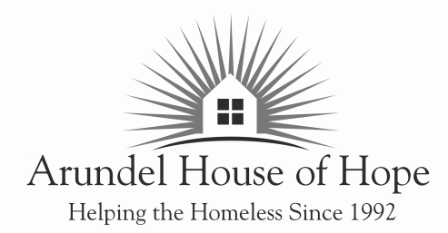

Page 1 of 2

VOLUNTEER APPLICATION
THANK YOU for your interest in volunteering at the Arundel House of Hope. We deeply appreciate your interest, and hope that we can provide a welcoming and meaningful volunteer opportunity for you. To complete your application, simply fill out this two-page form and fax, mail, or deliver it in person to the address below. Please accept our warmest welcome to the Arundel House of Hope.

Arundel House of Hope Phone: (410) 863 – 4888
514 North Crain HWY, STE K Fax: (410) 863 – 7235
Glen Burnie MD, 21061 Email: info@arundelhoh.org

PERSONAL INFORMATION

First Name Last Name

Street Address City State ZIP Code

Home Phone:
Emergency Contact Name:

Cell Phone:

Email:
Emergency Contact Phone:

Preferred Contact Method:

VOLUNTEER PREFERENCES

AHOH Day Center or Community Recovery Center Micah 6 Project

Guest Advocate One-on-one Mentor

Day Center Case Management Assist with moving-ins

Day Center Office Admin Other

Day Center IT Support

CRC Group Facilitator (support groups, skills group, recreation groups)

Day Center/CRC OTHER

Page 2 of 2

VOLUNTEER AVAILABILITY (Please indicate the days and specific times you would like to volunteer)

 | MONDAY | TUESDAY | WEDNESDAY | THURSDAY | FRIDAY | SATRUDAY
AM
PM

VOLUNTEER BACKGROUND INFORMATION
Yes No
Have you ever: Been convicted of a criminal offense

Charged with neglect, abuse, or assault

Had your Driver’s License suspended or revoked

Been required to register as a sex offender

REFERENCES (non-family)

- _ _______________ __
First Name Last Name Phone

- _ _______________ __
First Name Last Name Phone

CONDITIONS OF VOLUNTEERING

- I agree to maintain complete confidentiality concerning all information I obtain, record, and/or observe concerning guest information and/or records kept on file.
- I agree to follow instructions from AHOH staff.
- I agree that my participation with AHOH in a volunteer capacity is entirely and completely voluntary. I agree that AHOH and/or its staff is not liable for any illness, injury, or loss of property I may sustain in the course of volunteering at AHOH.
- I agree to be responsible concerning the commitment I am making to volunteer. If I am volunteering for a regular shift-based position, I agree to do my best to meet the requirements of attendance for that shift, and that I will take reasonable actions to inform the appropriate AHOH staff should I be unable to meet my commitment on any given day.
- I agree that my volunteer status with AHOH may be terminated by AHOH should I demonstrate negligence in interacting with AHOH staff and/or guests, improper interactions with AHOH staff and/or guests, and/or other offenses as determined by AHOH management.
- I certify that all answers provided above are true and give permission for AHOH to take actions to verify my above answers.

SIGNED

First Name Last Name Date

